Val vs Var concept - Mutable vs. Immutable

Basic data types:

Data types are the classification or categorization of data items. It represents the kind of value that tells what operations can be performed on a particular data. Since everything is an object in Python programming, data types are actually classes and variables are instances (object) of these classes.

Following are the standard or built-in data type of Python:

1. Numeric - Integer/ Complex number/ Float
2. Sequence type - Strings/ List/ Tuple
3. Boolean
4. Set
5. Dictionary

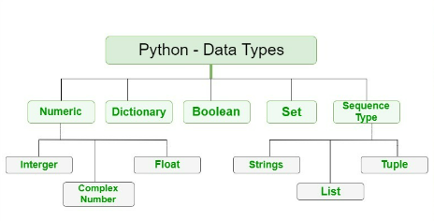

**Numeric data type:**

These values are defined as int, float and complex classes in Python.

* **Integers** – This value is represented by int class. It contains positive or negative whole numbers (without fraction or decimal). In Python there is no limit to how long an integer value can be.
* **Float** – This value is represented by the float class. It is a real number with floating point representation. It is specified by a decimal point. Optionally, the character e or E followed by a positive or negative integer may be appended to specify scientific notation.
* **Complex Numbers** – Complex numbers are represented by complex classes. It is specified as (real part) + (imaginary part)j. For example – 2+3j

**Sequence data type:**

Sequence is the ordered collection of similar or different data types.

Sequence allows you to store multiple values in an organised and efficient fashion.

* **String** - In Python, [Strings](https://www.geeksforgeeks.org/python-strings/) are arrays of bytes representing Unicode characters. A string is a collection of one or more characters put in a single quote, double-quote or triple quote. In python there is no character data type, a character is a string of length one. It is represented by str class.
* **List** - Lists are like arrays in other languages. It is flexible as the items in a list do not need to be of the same type.
* **Tuple** - Tuple is also an ordered collection of Python objects. Difference between tuple and list is that tuple is immutable.

**Boolean data type:**

Data type with one of the two built in values True/False.

Capital T and F are the only valid boolean values.

**Set data type:**

Set is an unordered collection of data type that is iterable, mutable and has no duplicate elements. The order of the elements in the set is not defined.

Sets can be created by using the built-in set() function with an iterable object or a sequence by placing the sequence inside curly braces, separated by ‘comma’. Type of elements in a set need not be the same, various mixed-up data type values can also be passed to the set.

**Dictionary data type:**

Dictionaries in python is an unordered collection of data values, used to store data values.

In Python, a Dictionary can be created by placing a sequence of elements within curly {} braces, separated by ‘comma’. Values in a dictionary can be of any datatype and can be duplicated, whereas keys can’t be repeated and must be immutable. Dictionary can also be created by the built-in function dict(). An empty dictionary can be created by just placing it to curly braces{}.

#### **None:**

The None type includes a single value None, used to indicate the absence of a value. None has the type NoneType. It is often used to declare a variable whose value may be assigned later.

Python supports basic arithmetic operations